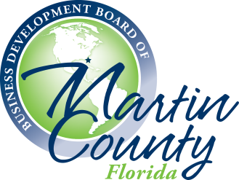

Business Development Board of Martin County, Inc.
BDBMC BOARD MEETING AGENDA (VIRTUAL)

Wednesday, September 16, 2020 - 8:30 – 9:45 a.m.
Join by Video: Join online: https://itsfiber.accessionmeeting.com/j/1160111678
Join by Phone: Dial: 772-597-6338; Meeting ID: 116 011 1678

- 8:30 am Call to Order and Welcome – Angela Hoffman, President of the Board of Directors

2. 8:35 am Public Comments

3. 8:45 am Partner Comments

4. 8:50 am Approval of August 12, 2020 Minutes (Action Item) – Angela Hoffman

5. 8:55 am Approval of July 2020 Financials (Action Item) – Jamil Mikati, Treasurer

6. 9:00 a.m. Approval of FY 2021 Directors and Officers (Action Items) – Angela Hoffman

7. 9:05 a.m. Year in Review and Director Recognition – Angela Hoffman and Charlie Page

8. 9:20 a.m. Martin County Real Estate Update – Marty Carmody, Olde Florida Realty

9. 9:25 am Executive Director and Team Reports
a. Business Development Activity | New Initiative Announcement – “Thrive in 45”
b. Marine Industry Roundtable Recap
c. Future of Work and Learning Roundtable
e. Strategic Communications
f. 2020 MC Business Awards – Nomination Period Now Open

10. 9:40 am Board Member Comments / Announcements

11. 9:45 am Adjournment

Upcoming Meetings | Events
BDBMC Nominating Committee: Wednesday, September 16, 2020, 8:00 a.m. (Virtual)
The Future of Work and Learning Roundtable: Friday, September 25, 2020 (In-Person)
BDBMC Executive Committee Meeting: Wednesday, September 30, 2020, 3:30 p.m. (New Date, Virtual)
BDBMC Board of Directors’ Meeting – Wednesday, October 14, 2020, 8:30 a.m. (Virtual)
9/13/2020 10:56 AM

