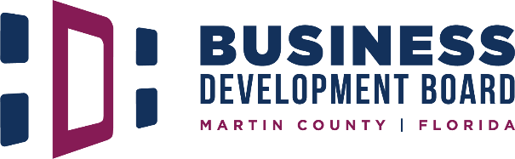

Budget Workshop Agenda, Friday, May 10, 2024 – 8:30 – 10:00 am
Children’s Services Council of Martin County, 101 SE Central Pkwy, Stuart, FL 34994

- 8:30 am Call to Order and Roll Call – Susan Rabinowitz, President

- 8:30 am Comments
    - Partners
    - Public
- N/A Approvals

- 8:35 am Discussions
    - Review and discuss proposed budget for Fiscal Year 2024-2025

- N/A Reports | Presentations

- 9:50 am Director Comments
- 10:00 am Adjourn

Upcoming Meetings | Events
SFMA Manufacturing Breakfast, Wednesday, May 15, 2024 – 8:30 am
Indian River State College, Chastain Campus, Bldg. C, 2400 Salerno Road, Stuart
Distinguished Speaker Event, Monday June 3, 2024 – 11:00 am
Hutchinson Shores Resort and Spa, 3793 NE Ocean Blvd, Jensen Beach

